**Install Docker Engine on CentOS**

* Sudo yum remove docker \docker-client \ docker-client-latest \ docker-common \ docker-latest \ docker-latest-logrotate \ docker-logrotate \ docker-engine
* sudo yum install -y yum-utils

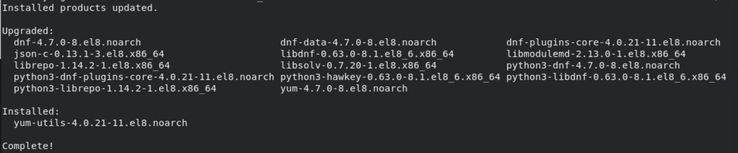

* sudo yum-config-manager --add-repo \ <https://download.docker.com/linux/centos/docker-ce.repo>



* sudo yum install docker-ce docker-ce-cli containerd.io docker-compose-plugin --allowerasing

* sudo systemctl start docker
* sudo docker run hello-world

**aac platform docker container image creation**

* vim Dockerfile

* vim requirements-dev.txt

* docker build -t jiarchenlinux/run:v1 .

**aac-tool docker container image creation**

**On VM**

* python3 -m pip install –user pipx



* python3 -m pipx ensurepath

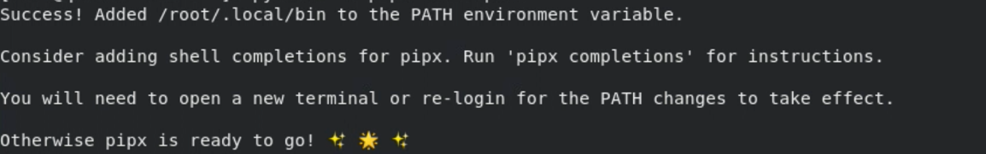

**Local PC/MAC**

* https://containers.cisco.com/repository/aide/aac-tool

docker pull containers.cisco.com/aide/aac-tool

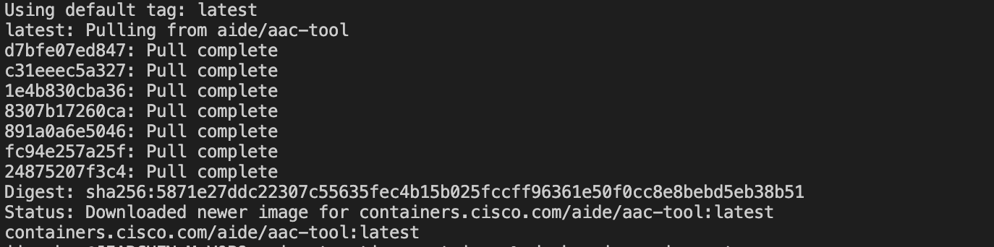

* docker run -v /var/run/docker.sock:/var/run/docker.sock --rm alpine/dfimage \

-sV=1.36 [containers.cisco.com/aide/aac-tool:latest](https://containers.cisco.com/aide/aac-tool:latest)

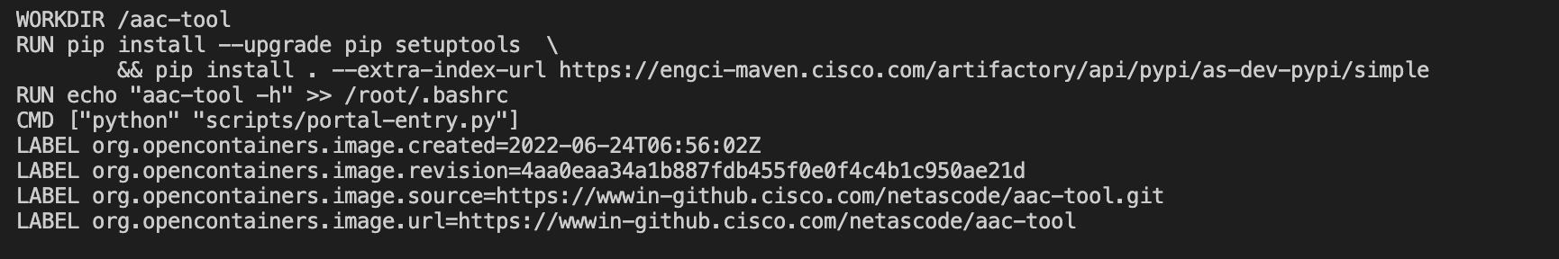

* docker save containers.cisco.com/aide/aac-tool:latest > aac-tool20220901.tar
* sudo tar -zcvf aac-tool20220901.tar.gz aac-tool20220901.tar

Upload through Git LFS and download the file to VM

1. Create a repo on GitHub.
2. Download Git LFS at <https://git-lfs.github.com/>
3. Copy file to a local directory, like: /Users/jiarchen/Downloads/ctbc2/.git/

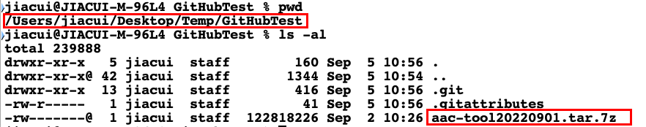

1. Git init – follow GitHub repo guide, like:

git add README.md

git remote add origin https://github.com/jiarchen12/CTBC.git

git branch -M main

1. Git LFS upload:

git lfs install

git lfs track "*.gz"

git add .gitattributes

git add aac-tool20220901.tar.gz

git commit -m "Add design file"

git push origin main

1. Check file upload status from GitHub

Back on VM

* Yum install git-lfs

* Git lfs clone https://github.com/jiarchen12/CTBC.git

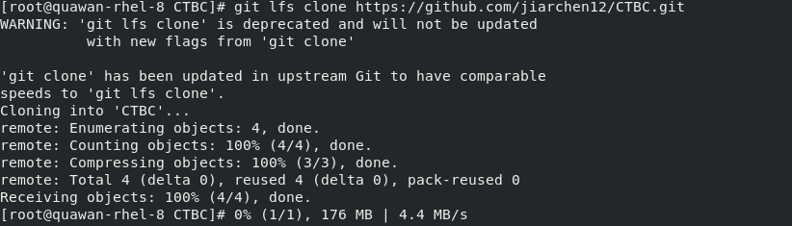

* Tar -zxvf aac-tool20220901.tar.gz
* Docker load -I aac-tool20220901.tar

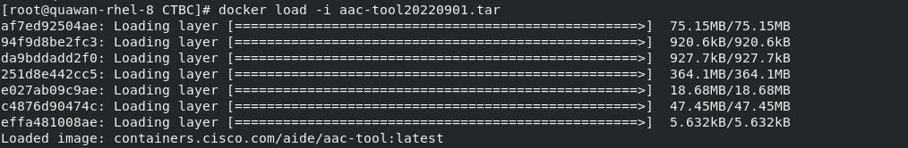

* Docker images

* docker run -v /var/run/docker.sock:/var/run/docker.sock --rm alpine/dfimage \

-sV=1.36 [containers.cisco.com/aide/aac-tool:latest](https://containers.cisco.com/aide/aac-tool:latest)

